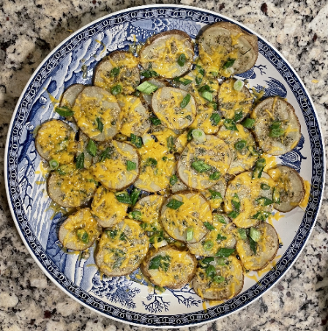
Ingredients:
- 2 medium potatoes
- 2 Tbsp butter
- 1/2 tsp dried oregano
- 1/2 tsp dried parsley
- 1/2 tsp garlic powder
- 1/2 tsp onion powder
- 1/4 tsp salt
- 1/8 tsp pepper
- 2 Tbsp grated parmesan cheese
- 2 scallions (green onion) - optional
- 1/3 cup cheddar cheese

Directions:
- Scrub potatoes. Cut potatoes into 1/4 inch thick slices (or thinly slice for variation.)
- Measure all spices and parmesan cheese in bowl and mix thoroughly.
- Melt butter in 2 cup liquid measuring cup in microwave for 30 seconds (cover with a paper towel to prevent splatter).
- Arrange a layer of potato slices, putting the smaller slices in the center.
- Using a pastry brush, evenly coat the potatoes with butter. Sprinkle ½ the spices and parmesan mixture evenly over the potatoes.
- Arrange the second layer on top staggering the potatoes, and repeat step 5.
- Cut green onion on a bias cut and sprinkle over potatoes.
- Cover completely with an inverted plate – do not vent.
- Cook on 100% power (high) for 7 to 10 minutes. (8 minutes in school microwave.)
- Test a few potatoes for doneness with a fork – the fork should easily go into the potato.
- Sprinkle with cheddar cheese.
- Cook, UNCOVERED, for 60 seconds or until cheese is melted.

*Serve warm*

